**Introduction to Database Project for Fall 2022-23 submitted to MR. MD. SAJID BIN FAISAL** **Title as** **“Cricket Team Management”  
Section:T  
Group:1**

|  |  |
| --- | --- |
| **NAME** | **ID** |
| **NIDAN ALAM** | **22-47046-1** |

Page 1

**TABLE OF CONTENT :**

**1. Scenario Page - 3**

**2.ER-Diagram Page - 4**

**3.Normalization Page - 5**

**4.Finalization Page - 11**

**5.Table Creation Page - 12**

**6.Value Insertion Page - 19**

**7.Query Test Page - 31**

**8.Conclusion Page - 38**

Page 2

**Scenario:**A Computer science cricket team management system has three departments. Players , coaches and Staffs. Players , coaches and staff are Identified by their ID. Players has attribute PID, Pname ,phone ,age and address. Coaches has attribute of CID , Cname , phone and Staff has attributes like SID , Sname ,phone .In a Cricket team there are many players and at least one coach and at least one staff. Players are specified as Batsman, Bowler and All-Rounder. At least one player is trained by each coach. A CS cricket team can have maximum one sponsor for their team. Sponsors have their Unique ID , name and amount. At least a Cricket team plays in APL .APL is Identified by Match ID and has Attribute of M_loc and date. Many Audience comes to watch APL. Audience have their own unique ID and also have name. APL is managed by AIUB Authority. They have a unique ID, name.

Page 3

**ER – Diagram :**

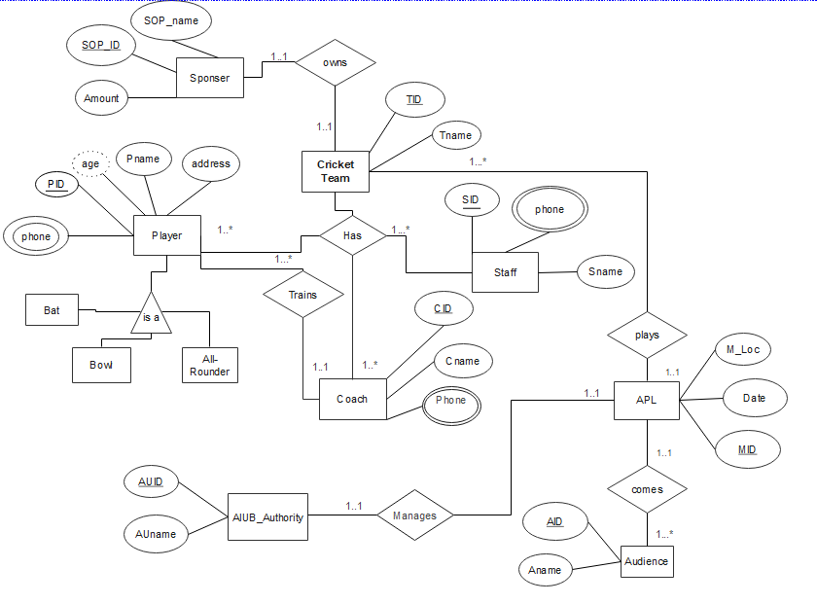

Page 4

**Normalization :**

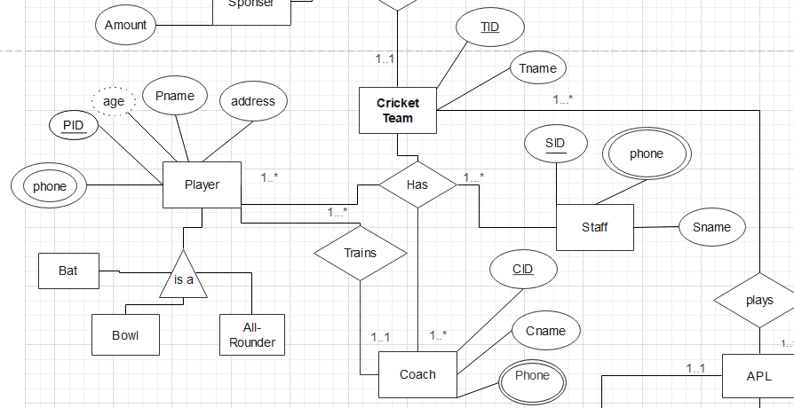

Has Relation:  
 **UNF:**TID , Tname , PID ,Pname , age , phone , address , CID , Cname , phone , SID , Sname , Phone  
  
**1NF:**

i)TID , Tname , PID ,Pname , age , phone , address , CID , Cname , phone , SID , Sname , Phone  
  
**2NF :**

i)TID , Tname

ii) PID ,Pname , age , phone , address , TID(FK)

iii)CID , Cname , phone , TID(FK)

Page 5

iv) SID , Sname , Phone , TID(FK)

**3NF** will be same as **2NF**

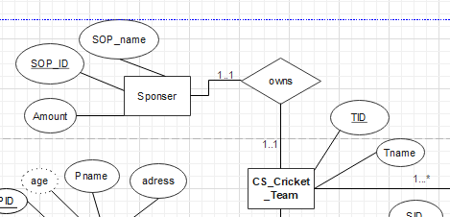

OWNS RELATION: **UNF:**

TID , Tname , SOP_ID , SOP_name , Amount   
  
**1NF:**   
i) TID , Tname , SOP_ID , SOP_name , Amount

**2NF:**i) TID , Tname

ii) SOP_ID , SOP_name , Amount  
iii) TID , SOP_ID(FK)

**3NF** will be same as **2NF**

Page 6

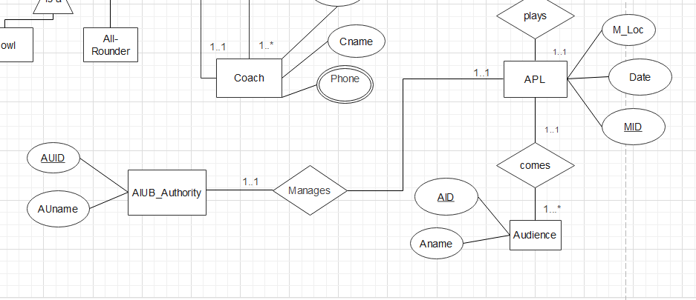MANAGES RELATION : **UNF:**

MID , M_Loc ,Date, AUID , AUname   
  
**1NF:**   
i) MID , M_Loc ,Date, AUID , AUname   
**2NF:**i) MID , M_Loc , Date

ii) AUID , AUname   
iii) MID , AUID(FK)

**3NF** will be same as **2NF**

Page 7

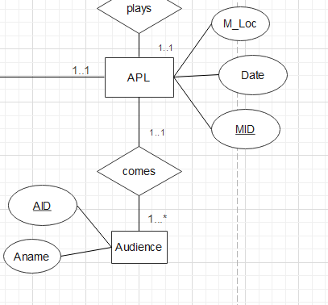

COMES RELATION:

**UNF:**

MID , M_Loc ,Date, AID , Aname   
  
**1NF:**   
i) MID , M_Loc ,Date, AID , Aname   
**2NF:**i) MID , M_Loc , Date

ii) AID , AUname , MID (FK)

**3NF** will be same as **2NF**

Page 8

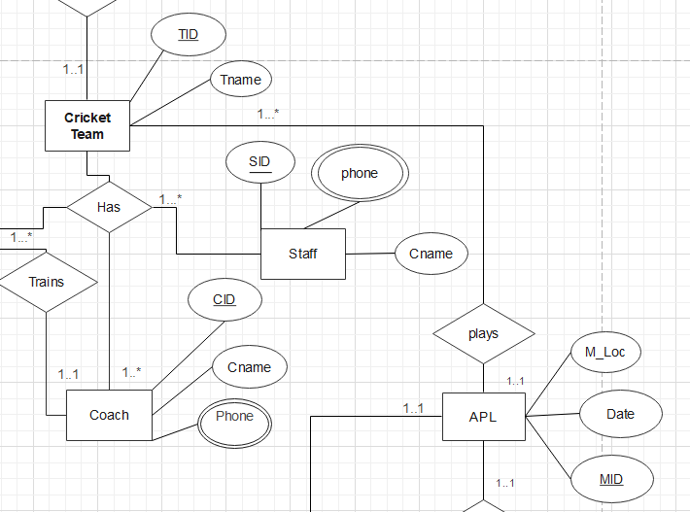

PLAYS RELATION : **UNF:**

MID , M_Loc ,Date, TID , Tname   
  
**1NF:**   
i) MID , M_Loc ,Date, TID , Tname   
**2NF:**i) MID , M_Loc , Date

ii) TID , Tname , MID (FK)

**3NF** will be same as **2NF**

Page 9

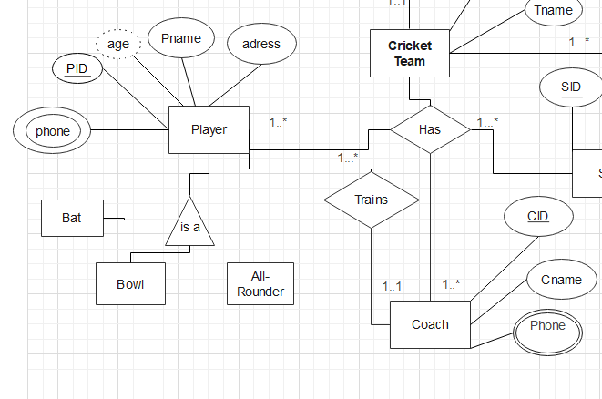

Trains Relation:

**UNF:** PID ,Pname , age , phone , address , CID , Cname , phone  
  
**1NF:**

i) PID ,Pname, age , phone , address , CID , Cname , phone  
  
**2NF :**

i) PID ,Pname , age , phone , address , CID(FK)

ii)CID , Cname , phone

**3NF** will be same as **2NF**

Page 10

**Finalization :**

i)TID , Tname

ii) PID ,Pname , age , phone , address , TID(FK)

iii)CID , Cname , phone , TID(FK)

iv) SID , Sname , Phone , TID(FK)

v) SOP_ID , SOP_name , Amount  
vi) TID , SOP_ID(FK)  
vii) MID , M_Loc , Date

viii) AUID , AUname

ix) MID , AUID(FK)

x) TID , Tname , MID (FK)  
xi) PID ,Pname , age , phone , address , CID(FK)

xii)CID , Cname , phone

Page 11

**Table creation :**i)TID , Tname   
  
  
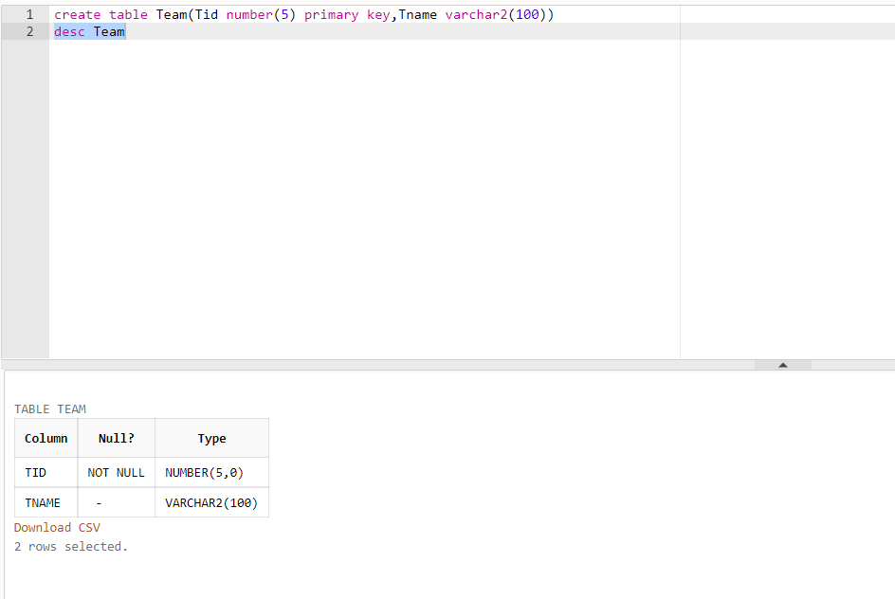ii) PID ,Pname , age , phone , address , TID(FK)

Page 12

iii)CID , Cname , phone , TID(FK)

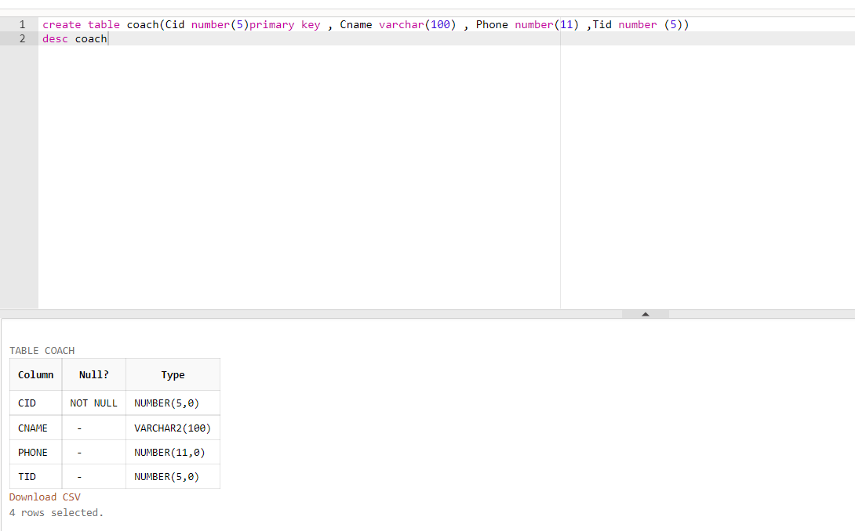

Page 13

iv) SID , Sname , Phone , TID(FK)

Page 14

vi) TID (FK), SOP_ID  
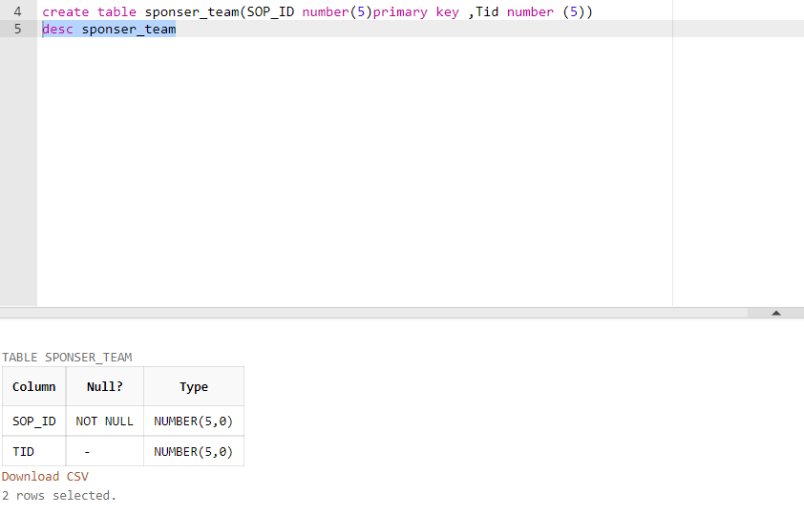

Page 15

viii) AUID , AUname

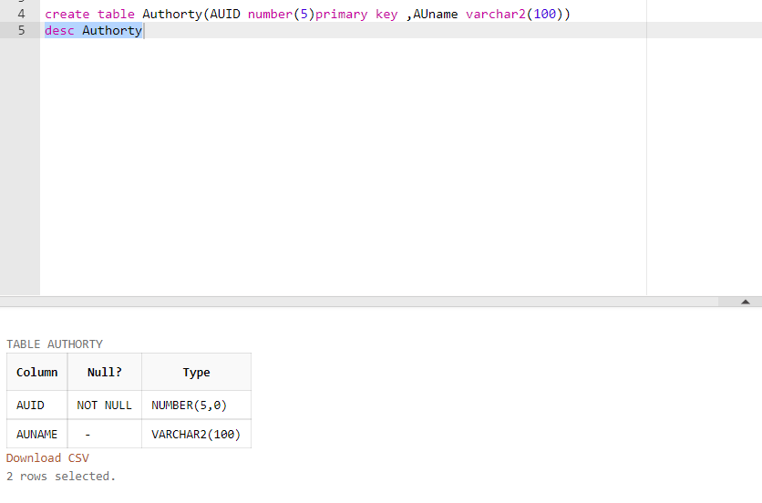

ix) MID , AUID(FK)

Page 16

x) TID , Tname , MID (FK)

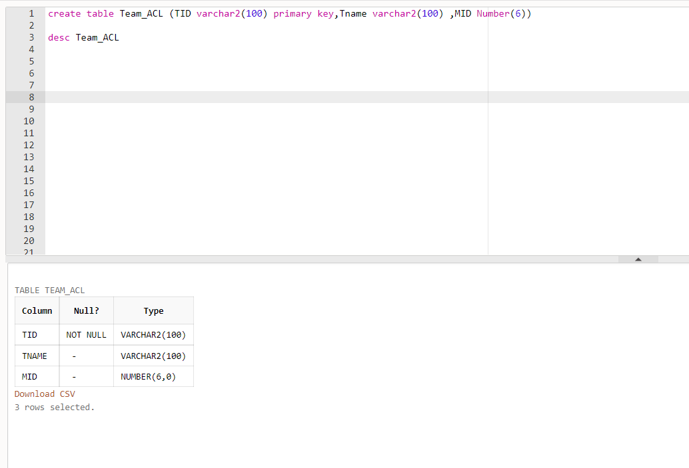

xi) PID ,Pname , age , phone , address , CID(FK)

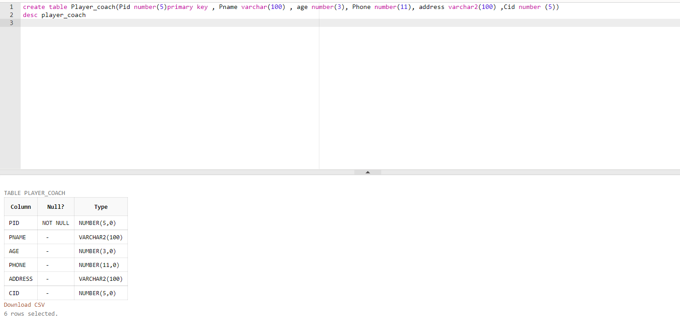

Page 17

xii)CID , Cname , phone

Page 18

**Value Insertion :   
  
Team :  
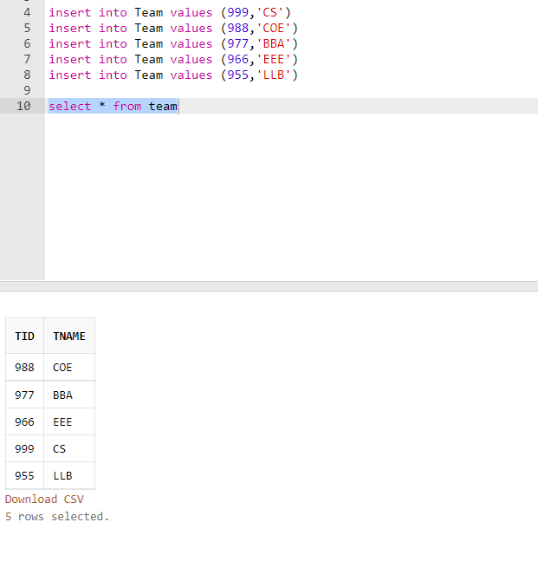  
  
Player:  
  
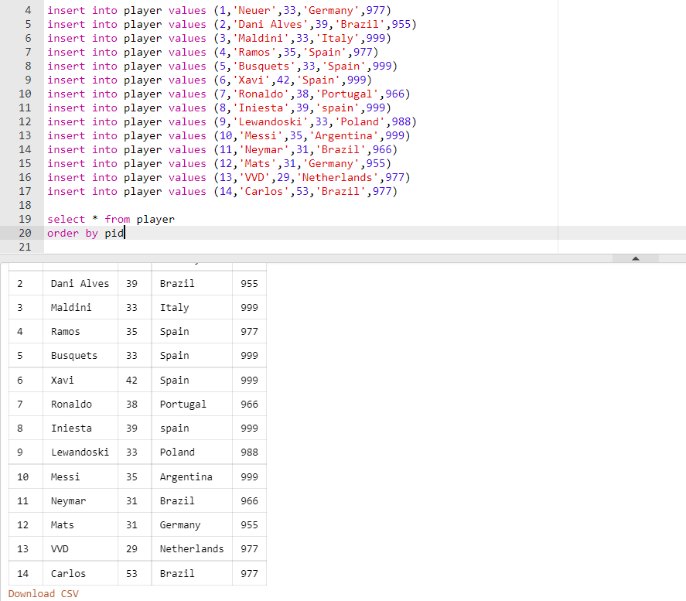  
  
Coach :  
  
  
Staff :**

Page 19

Page 20

Page 21

**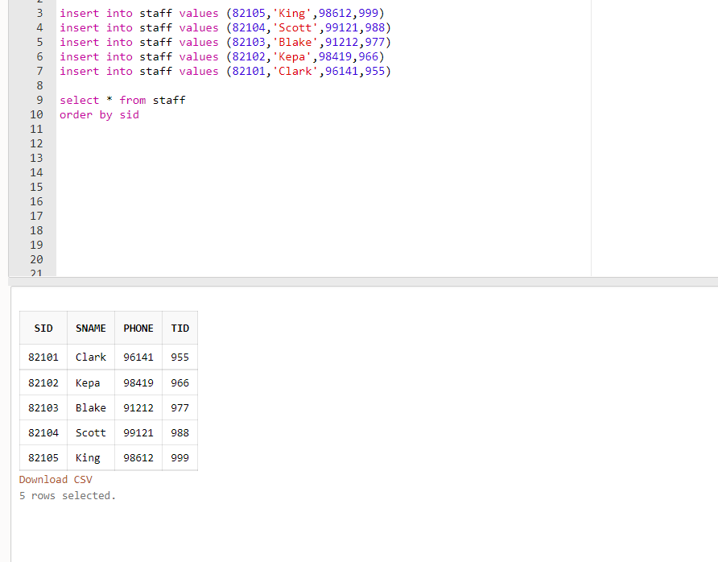  
  
SP0NSER:**

Page 22

**  
  
Sponsor_Team:**

Page 23

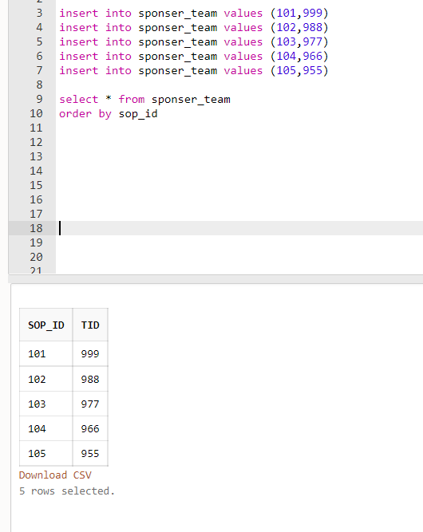

**ACL :**

Page 24

Page 25

**Authority :  
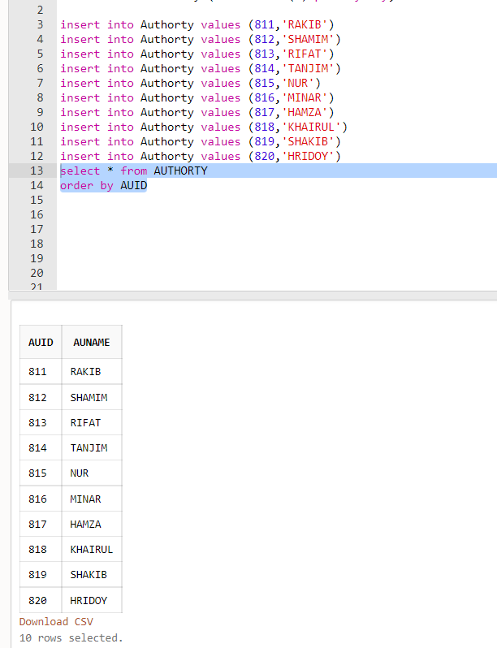**

Page 26

**Authorty_ACL :  
**

**Team_ACL :**

Page 27

**Player_Coach:**

Page 28

**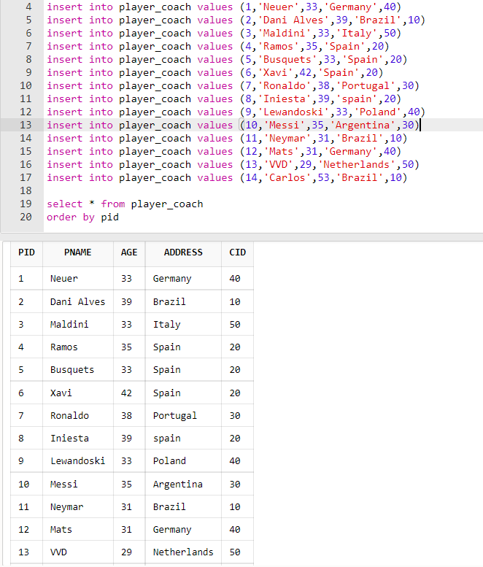  
  
coach_team :**

Page 29

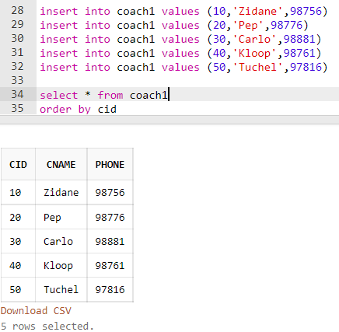

Page 30

**QUERY TEST :**

**Single-Row Query:**

1. **Show Team ID and Team Name of Team Table of ID No 999 .**

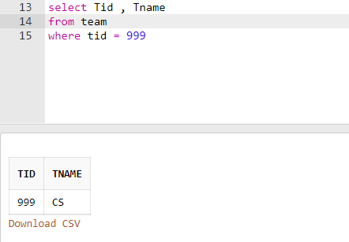

**Multiple-Row Query:**

**1. Show players Name, Age and ID from player Table who are playing for Team ID 999.**

Page 31

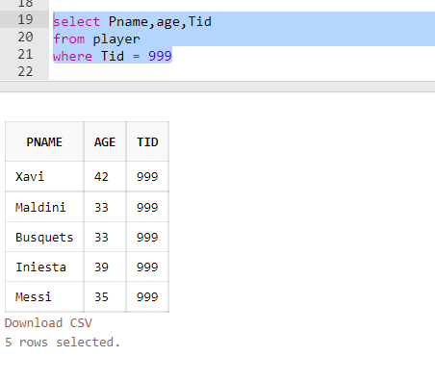

**Aggregate Query:**

**Sub-query:**

**\*Single Row :**

**1. Show name and id from coach table of coaches having less id no of team id no 999.**

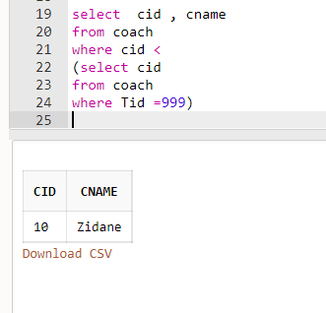

Page 32

**2. Show Match Id and location before ‘2-mar-22’ from ACL table**

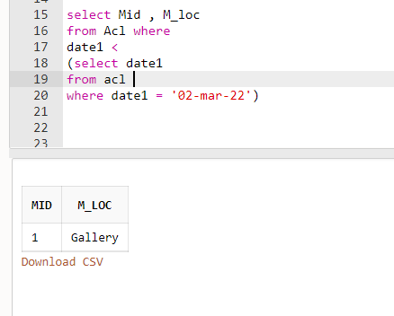

**\*Multiple Row :**

**1. Show Id and Name from coach table of all having less ID no than ‘Tuchel’**

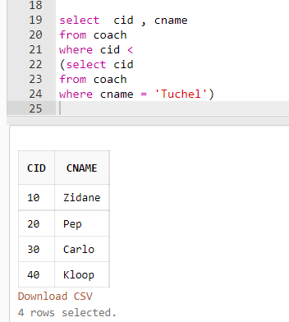

**2. Show name ,age and address of all players younger than Messi from player_coach table**

Page 33

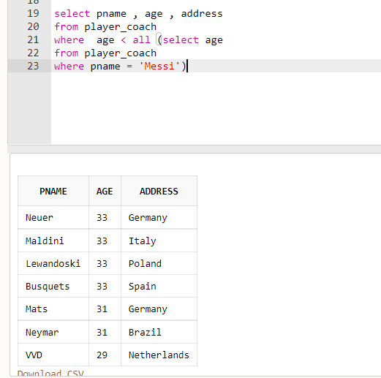

**Aggregation :**

**1. Show the cid , address and the sum of age from player_coach table group by address and cid**

Page 34

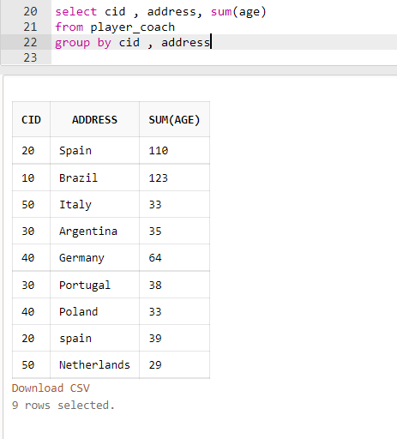

**JOINING :**

**Outer_Join :**

**1. Show Authority ID no. who didn’t participated in ACL from Authority_ACL and Authority table**

Page 35

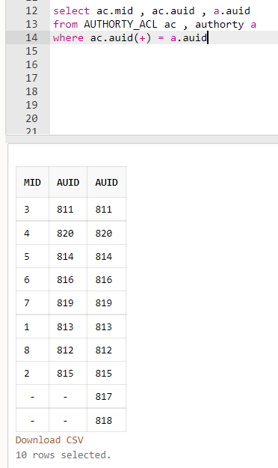

**EqiuJoin :**

**1. Show date , auid and mid in descending order from acl and Authority_ACl table**

Page 36

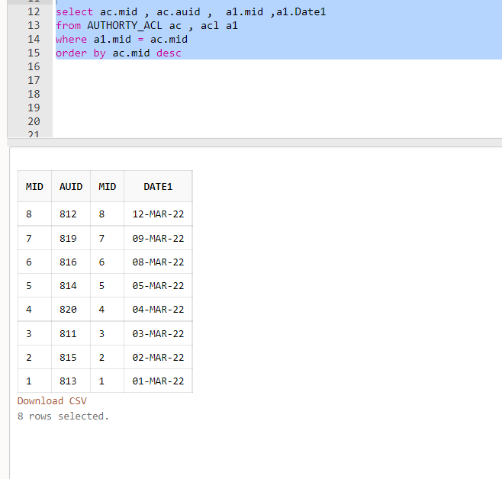

**View Create :**

**1. create a view for Coach 2 who can only view Coach ID , Team ID and Coach Name from Coach table**

Page 37

**Conclusion:**

**“Cricket Management” Schema can be used in Sporting Database System. It can help to store data of Coach, Player, Tournament, Staff, Sponsor and Authority. Using this schema user can store the data. I learnt creating schema for a Database System.**

Page 38